SIMATS ENGINEERING (SAVEETHA SCHOOL OF ENGINEERING)
Department of Computer Science and Engineering

ASSESSMENT TOOL 3 – Comparative Analysis

Course Code: | CSA06 | Course Title: | Design and Analysis of Algorithms
CO Assessed: | CO4: Articulation (BL4, BL5) | Assessment: | Assessment Tool 3 – Comparative Analysis
Weightage: | 10% of CIA | Total Marks: | 100 (2 Questions × 50 Marks)
CO4 Statement: | Solve optimization problems using dynamic programming and greedy strategies.
Student Name: | CH.Akhil | Reg. No.: | 192525250
Section / Batch: | 2025 | Date: | 26 08 26

Instructions to Students
- Answer both questions carefully. Each question carries 50 marks. Total: 100 marks.
- Analyze the given questions thoroughly before answering.
- Compare multiple aspects such as methods, results, advantages, and limitations clearly.
- Critically evaluate the strengths, weaknesses, and implications with proper justification.
- Present meaningful insights, interpretations, and well-supported conclusions from the comparisons.

Question Type | Description | Questions | Total Marks
Comparative Analysis | Focus on Comparison of different Algorithms using dynamic programming and greedy strategies. | Q1 – Q2 | 100

SECTION A – Comparative Analysis

1. Knapsack Comparison — DP vs Greedy
1.1 Problem Definition
The Knapsack Problem is an optimization problem in which a set of items has different weights and values. The objective is to select items such that the total weight does not exceed the given capacity while maximizing the total value.
There are two important versions:
- 0/1 Knapsack: An item is either completely selected or not selected.
- Fractional Knapsack: An item can be selected partially.
Given
- Weights = [10, 20, 30]
- Values = [60, 100, 120]
- Capacity = 50

1.2 0/1 Knapsack Using Dynamic Programming
In 0/1 Knapsack, each item can be selected at most once. Fractions of items are not allowed.
DP State
Let:
DP[i][w] = maximum value obtained using the first i items with capacity w.
Recurrence Relation
If the weight of the current item is greater than the capacity:
$$DP\left[i\right]\left[w\right]=DP\left[i-1\right]\left[w\right]$$
Otherwise:
$$DP\left[i\right]\left[w\right]=max⁡\left(D , P\left[i-1\right]\left[w\right]value_{i}+DP\left[i-1\right]\left[w-weight_{i}\right]\right)$$
Base Case
$$DP\left[0\right]\left[w\right]=0$$
and
$$DP\left[i\right]\left[0\right]=0$$
DP Table
For the given problem, the important final states are:
Items Considered | Capacity 10 | Capacity 20 | Capacity 30 | Capacity 40 | Capacity 50
0 items | 0 | 0 | 0 | 0 | 0
Item 1 (10,60) | 60 | 60 | 60 | 60 | 60
Item 2 (20,100) | 60 | 100 | 160 | 160 | 160
Item 3 (30,120) | 60 | 100 | 160 | 180 | 220
Therefore,
$$\boxed{Maximum Value=220}$$
Selected items:
- Item 2 → weight 20, value 100
- Item 3 → weight 30, value 120
Total weight:
$$20+30=50$$
Total value:
$$100+120=\boxed{220}$$
Complexity
- Time Complexity: O(nW)
- Space Complexity: O(nW)
where n is the number of items and W is the capacity.

1.3 Fractional Knapsack Using Greedy
In Fractional Knapsack, an item can be divided into smaller portions. The greedy strategy selects items according to their value-to-weight ratio.
Value/Weight Ratio
Item | Weight | Value | Value/Weight
1 | 10 | 60 | 6
2 | 20 | 100 | 5
3 | 30 | 120 | 4
The order is:
Item 1 → Item 2 → Item 3
Selection
Capacity = 50
First select Item 1:
$$10/10=1$$
Value = 60
Remaining capacity:
$$50-10=40$$
Select Item 2:
$$20/20=1$$
Value = 100
Remaining capacity:
$$40-20=20$$
Item 3 weighs 30, but only 20 capacity remains.
Therefore, take:
$$\frac{20}{30}=\frac{2}{3}$$
of Item 3.
Value obtained:
$$120×\frac{20}{30}=80$$
Total value:
$$60+100+80=\boxed{240}$$
Complexity
- Sorting: O(n log n)
- Selection: O(n)
- Overall: O(n log n)
- Space Complexity: O(n)

1.4 Comparison of 0/1 and Fractional Knapsack
Parameter | 0/1 Knapsack | Fractional Knapsack
Technique | Dynamic Programming | Greedy
Items | Cannot be divided | Can be divided
Maximum Value | 220 | 240
Selected items | Item 2 + Item 3 | Item 1 + Item 2 + 2/3 Item 3
Time Complexity | O(nW) | O(n log n)
Space Complexity | O(nW) | O(n)
Decision method | Considers combinations | Highest value/weight ratio
Optimality | Optimal for 0/1 problem | Optimal for fractional problem
Speed | Relatively slower | Faster
Main limitation | Higher memory requirement | Not suitable for general 0/1 problems

1.5 Strengths and Limitations
Dynamic Programming
Strengths:
- Guarantees an optimal solution for 0/1 Knapsack.
- Handles indivisible items.
- Considers different combinations of items.
- Provides a systematic solution.
Limitations:
- Requires more memory.
- Can be expensive when capacity is very large.
- More complex than the greedy approach.
Greedy
Strengths:
- Simple and easy to implement.
- Faster for Fractional Knapsack.
- Requires less memory.
- Gives an optimal solution for Fractional Knapsack.
Limitations:
- Cannot guarantee an optimal solution for general 0/1 Knapsack.
- Depends on the greedy-choice property.
- Cannot handle indivisible item selection optimally in general.

1.6 When Does Greedy Provide an Optimal Solution?
Greedy provides an optimal solution when the problem has the greedy-choice property and optimal substructure.
Fractional Knapsack satisfies these properties because an item can be divided. Therefore, selecting the highest value-to-weight ratio first always leads to an optimal solution.
For 0/1 Knapsack, items cannot be divided. Choosing the highest ratio item may prevent a better combination of complete items. Therefore, Dynamic Programming is necessary to guarantee the optimal result.

1.7 Critical Evaluation
For the given data, Dynamic Programming produces a value of 220, whereas Fractional Knapsack produces 240. The difference occurs because Fractional Knapsack allows 2/3 of the third item to be selected.
The greedy method is faster because it only needs to sort items according to their value-to-weight ratio. However, its optimality depends on the problem structure. Dynamic Programming is more computationally expensive but provides guaranteed optimality for the 0/1 Knapsack problem.

1.8 Insights on Method Selection
The choice between Dynamic Programming and Greedy should depend on the nature of the problem. If fractions are allowed, Fractional Knapsack can be efficiently solved using Greedy. If items must be selected completely, Dynamic Programming is more appropriate because it considers different combinations and guarantees the optimal 0/1 solution.
Conclusion
Dynamic Programming and Greedy algorithms solve different versions of the Knapsack problem effectively. For the given data, 0/1 Knapsack gives a maximum value of 220, while Fractional Knapsack gives 240. Greedy is faster and simpler but is optimal only when the problem satisfies the greedy-choice property. DP is preferable when item selection is indivisible and guaranteed optimality is required.

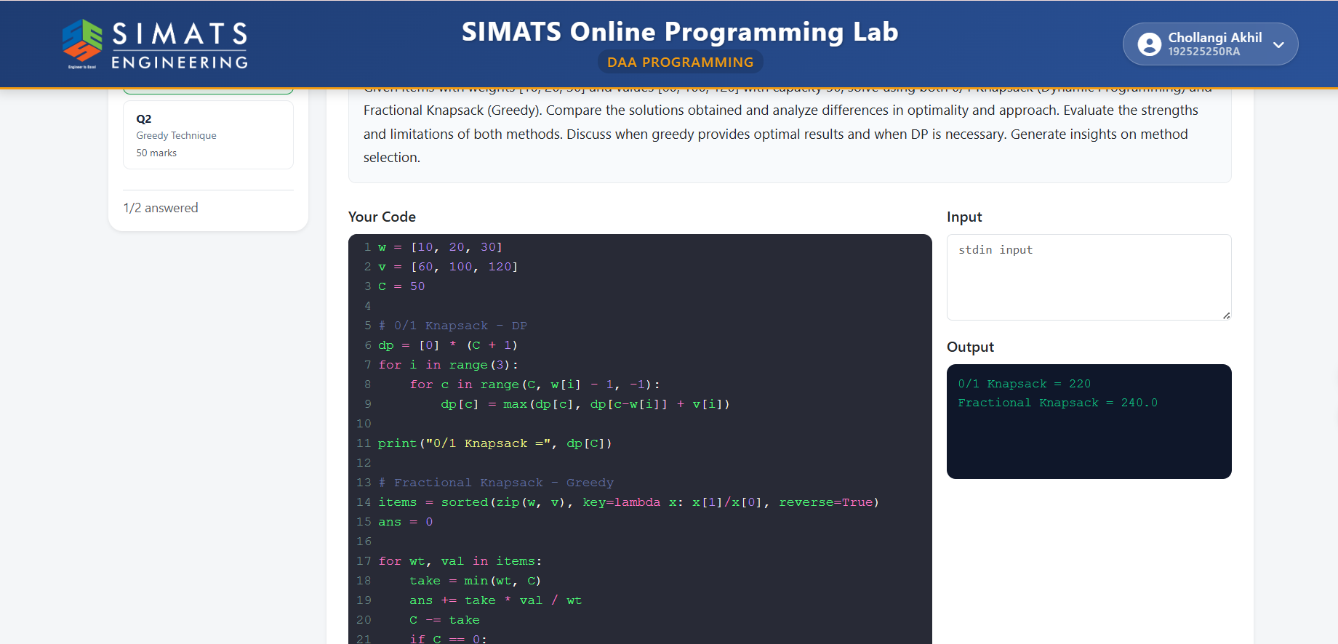

2. Shortest Path Comparison — Dijkstra vs Bellman-Ford
2.1 Problem Definition
The Shortest Path Problem finds the minimum-cost path from a source vertex to every other vertex in a weighted graph.
Two commonly used algorithms are:
- Dijkstra's Algorithm
- Bellman-Ford Algorithm
Dijkstra works correctly when all edge weights are non-negative. Bellman-Ford can handle negative-weight edges and can also detect negative-weight cycles.
Graph Used
Edge | Weight
A → B | 2
A → C | 5
C → B | -10
B → D | 2
C → D | 10
Source vertex = A

2.2 Dijkstra's Algorithm
Approach
Dijkstra uses a greedy strategy. It repeatedly selects the unvisited vertex with the smallest tentative distance and relaxes its outgoing edges.
Initial Distances
Vertex | Distance
A | 0
B | ∞
C | ∞
D | ∞
Step 1 — Start from A
From A:
- A → B = 2
- A → C = 5
Vertex | Distance
A | 0
B | 2
C | 5
D | ∞
Dijkstra selects B because its distance is 2.
Step 2 — Process B
B → D has weight 2:
$$2+2=4$$
Therefore:
Vertex | Distance
A | 0
B | 2
C | 5
D | 4
Dijkstra then selects D because its distance is 4.
Step 3 — Process C
C → B has weight -10:
$$5+\left(-10\right)=-5$$
This gives a better distance for B.
However, B has already been finalized by Dijkstra with distance 2.
Therefore, the standard Dijkstra algorithm cannot guarantee the correct result for this graph.
Correct Shortest Distances
The actual shortest paths are:
$$A→C=5 \\ A→C→B=5-10=-5 \\ A→C→B→D=5-10+2=-3$$
Therefore:
Vertex | Correct Distance
A | 0
B | -5
C | 5
D | -3

2.3 Bellman-Ford Algorithm
Approach
Bellman-Ford repeatedly relaxes every edge.
For a graph containing V vertices, all edges are relaxed V − 1 times.
Initial State
Vertex | Distance
A | 0
B | ∞
C | ∞
D | ∞
Relaxation Process
From A:
$$B=2, C=5$$
Then:
$$C→B$$
gives:
$$5+\left(-10\right)=-5$$
Therefore:
$$B=-5$$
Then:
$$B→D$$
gives:
$$-5+2=-3$$
Final Distances
Vertex | Shortest Distance
A | 0
B | -5
C | 5
D | -3
Shortest Paths
- A → C = 5
- A → C → B = -5
- A → C → B → D = -3

2.4 Complexity Analysis
Dijkstra
For a simple implementation:
$$O\left(V^{2}\right)$$
With a priority queue:
$$O\left(\left(V+E\right)\log{V}\right)$$
Space complexity:
$$O\left(V+E\right)$$
Bellman-Ford
Time complexity:
$$O\left(VE\right)$$
Space complexity:
$$O\left(V\right)$$

2.5 Dijkstra vs Bellman-Ford Comparison
Parameter | Dijkstra | Bellman-Ford
Approach | Greedy | Repeated edge relaxation
Negative edges | ❌ Not guaranteed correct | ✅ Supported
Negative cycle detection | ❌ No | ✅ Yes
Simple time complexity | O(V²) | O(VE)
Priority queue version | O((V+E)logV) | —
Speed | Faster | Slower
Correct with negative edges | No | Yes
Main advantage | Efficient | Handles negative weights
Main limitation | Fails with negative edges | Higher computational cost
Best application | Non-negative weighted graphs | Graphs with negative weights

2.6 Why Does Dijkstra Fail?
Dijkstra assumes that once a vertex with the smallest tentative distance is selected, its distance is final.
This assumption is valid when all edge weights are non-negative.
In the given graph:
$$A→B=2$$
So Dijkstra initially considers B to have distance 2.
However:
$$A→C→B$$
has cost:
$$5+\left(-10\right)=-5$$
Thus, B can be reached with a smaller distance after Dijkstra has already finalized B.
Therefore, the greedy assumption is violated.

2.7 Correctness Analysis
Dijkstra
Dijkstra is correct when:
$$\boxed{\text{All edge weights}≥0}$$
It is efficient but cannot generally handle negative-weight edges.
Bellman-Ford
Bellman-Ford works with:
- Positive edges
- Zero-weight edges
- Negative edges
It also detects reachable negative-weight cycles.
If a negative cycle exists, a finite shortest path may not exist because the path cost can continue decreasing indefinitely.

2.8 Performance Analysis
Dijkstra is generally faster than Bellman-Ford. For graphs with only non-negative edge weights, Dijkstra is usually the better choice.
Bellman-Ford requires repeated relaxation of all edges, resulting in O(VE) time. However, its additional computational cost provides an important advantage: it can correctly process negative-weight edges and detect negative cycles.

2.9 Strengths and Limitations
Dijkstra
Strengths:
- Fast.
- Efficient for large graphs with non-negative weights.
- Simple greedy approach.
- Works well with priority queues.
Limitations:
- Cannot guarantee correct results with negative-weight edges.
- Cannot detect negative-weight cycles.
Bellman-Ford
Strengths:
- Handles negative-weight edges.
- Detects negative-weight cycles.
- Can be applied to a wider range of weighted graphs.
Limitations:
- Slower than Dijkstra.
- Requires repeated processing of edges.
- Less efficient for very large graphs.

2.10 Critical Evaluation
Dijkstra's algorithm is more efficient because it uses a greedy strategy and permanently selects the vertex with the smallest tentative distance. However, this strategy relies on the assumption that no later edge can reduce a finalized distance. Negative edges violate this assumption.
Bellman-Ford does not make this assumption. By repeatedly relaxing all edges, it can discover shorter paths created through negative-weight edges. The trade-off is increased computational cost.

2.11 Insights on Algorithm Selection
The graph's edge weights should determine the algorithm selection.
- No negative edges → Dijkstra
- Negative edges → Bellman-Ford
- Negative-cycle detection required → Bellman-Ford
Therefore, Dijkstra should be selected when performance is important and all edge weights are non-negative. Bellman-Ford should be selected when negative edge weights are present or negative-cycle detection is required.

2.12 Conclusion
Dijkstra and Bellman-Ford are both shortest-path algorithms, but they differ significantly in their assumptions and performance. Dijkstra is faster and uses a greedy strategy, but it requires non-negative edge weights. Bellman-Ford is slower because it repeatedly relaxes all edges, but it correctly handles negative-weight edges and can detect negative-weight cycles. Therefore, Dijkstra is preferred for non-negative weighted graphs, while Bellman-Ford is necessary when negative weights are present.

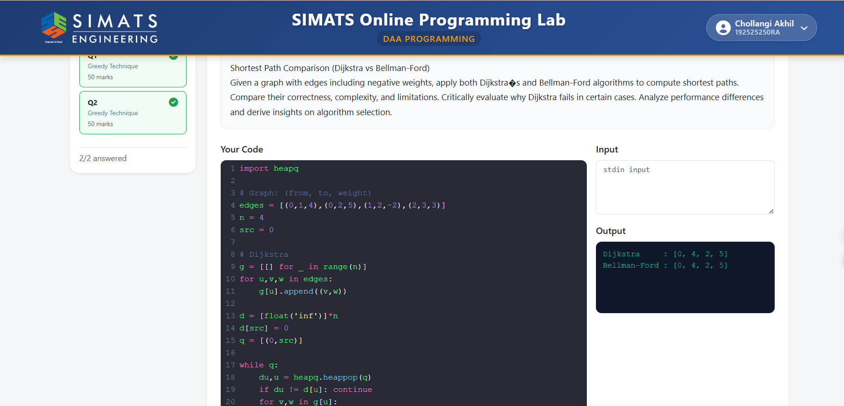

Code of Conduct
I CH.Akhil (192525250) certify that this submission is my original work and that I have adhered to the guidelines specified for this assessment. I understand that any violation of academic integrity rules will result in disciplinary action.
Signature of the Student: akhil

RUBRICS FOR CALCULATION

 |  | Comparative Analysis
Criteria | Weightage | Level 4 (Exemplary) | Level 3 (Proficient) | Level 2 (Developing) | Level 1 (Beginning)
Selection of Studies/Parameters | 20% | Selects highly relevant and diverse studies with well-defined comparison parameters | Selects relevant studies with minor gaps in parameter definition | Limited or partially relevant selection | Poor or inappropriate selection of studies
Comparison & Differentiation | 25% | Clearly compares multiple aspects (methods, results, limitations) with strong differentiation | Good comparison with minor gaps | Basic comparison with limited depth | No clear comparison; mostly descriptive
Critical Evaluation | 25% | Critically evaluates strengths, weaknesses, and implications with strong justification | Provides evaluation with some justification | Limited evaluation; lacks depth | No critical evaluation provided
Synthesis & Insight Generation | 20% | Generates meaningful insights and conclusions from comparisons | Some insights derived from comparison | Limited or unclear insights | No insights generated
Clarity | 10% | Information is clearly presented  (tables/figures) with logical structure | Generally clear with minor issues | Presentation lacks clarity or structure | Poor presentation and difficult to understand

Mark Evaluation:

Questions | Selection of  Studies/Parameter s (20) | Comparison &  Differentiatio n  (25) | Critical  Evaluation  (25) | Synthesis & Insight  Generation  (20) | Clarity  (10) | Total Marks (Each - 50)
Q1
Q2
 |  |  |  | Overall Total

Faculty In-charge | Course Coordinator | Head of Department
Name: __________________  Signature: _______________ | Signature: _______________ | Signature: _______________
Date: ___________________ | Date: ___________________ | Date: ___________________

